C.Tharun
(192472309)
Exp No: 9
ULTRASONIC SENSOR IN PROTEUS USING ARDUINO
AIM:
To write an Embedded C program for interfacing Ultrasonic Sensor using Arduino Uno and Proteus

SOFTWARE REQUIRED:
- Proteus 8 software.
- Arduino IDE software

CIRCUIT DIAGRAM:
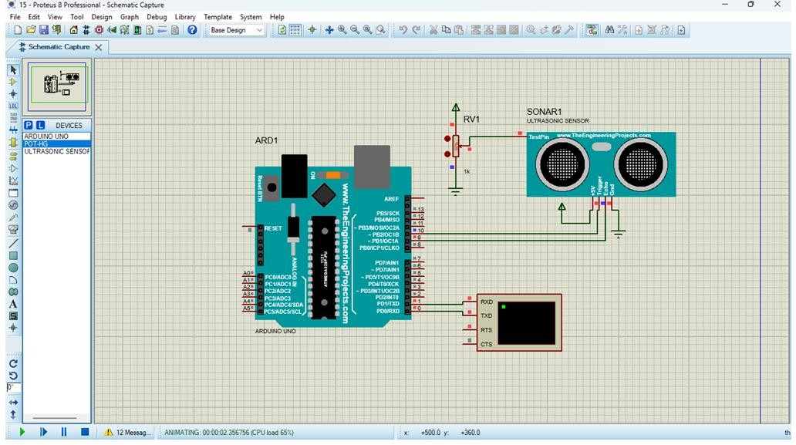
PROGRAM:
// Program Sketch int trig = 10; int echo = 9; long duration; int cm;
void setup() {
// put your setup code here, to run once:
pinMode(trig, OUTPUT); pinMode(echo,INPUT);
Serial.begin(9600);
}
void loop() { // Sketch to calculate ultrasonic distance digitalWrite(trig, LOW); delayMicroseconds(10); digitalWrite(trig, HIGH); delayMicroseconds(10); digitalWrite(trig, LOW); delayMicroseconds(10); duration = pulseIn(echo, HIGH); cm = (duration/2) * 0.034; // Print Value on Serial Monitor
Serial.print(" Distance = ");
Serial.print(cm);
Serial.println(" cm");
}

OUTPUT:
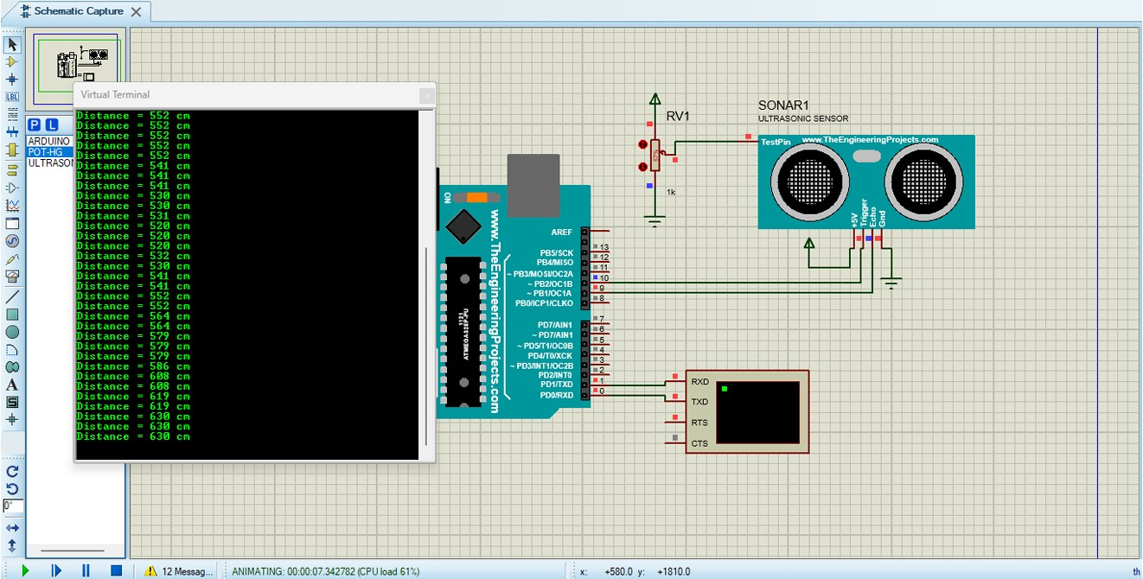
RESULT:
Thus the program has been successfully verified and executed.

